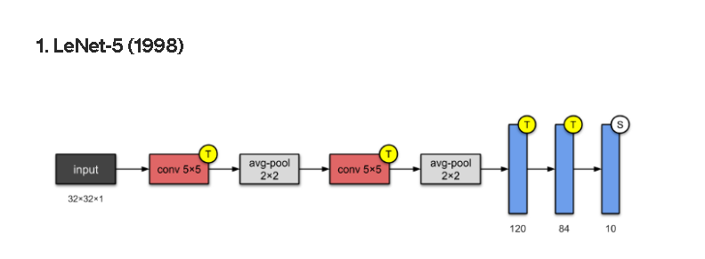Q: what are CNN model’s names?

1. [LeNet-5](https://towardsdatascience.com/illustrated-10-cnn-architectures-95d78ace614d#e276)
2. [AlexNet](https://towardsdatascience.com/illustrated-10-cnn-architectures-95d78ace614d#e971)
3. 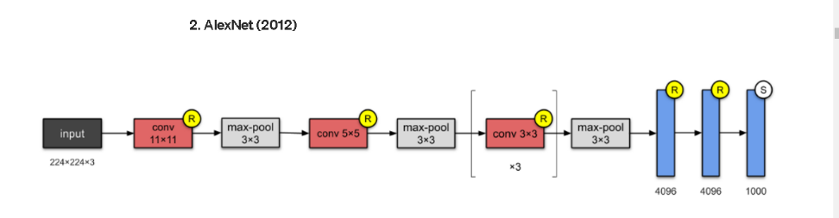[VGG-16](https://towardsdatascience.com/illustrated-10-cnn-architectures-95d78ace614d#c5a6)
4. [Inception-v1](https://towardsdatascience.com/illustrated-10-cnn-architectures-95d78ace614d#81e0)
5. [Inception-v3](https://towardsdatascience.com/illustrated-10-cnn-architectures-95d78ace614d#6872)
6. 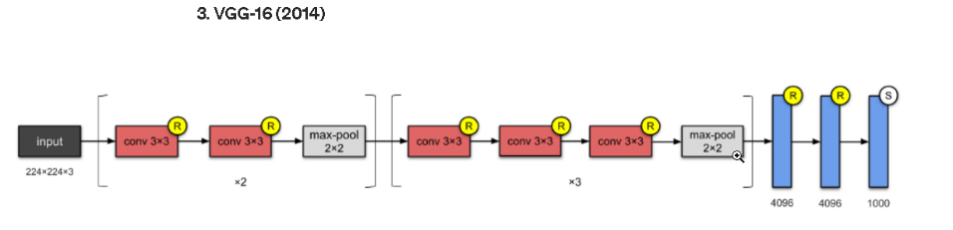[ResNet-50](https://towardsdatascience.com/illustrated-10-cnn-architectures-95d78ace614d#e4b1)
7. [Xception](https://towardsdatascience.com/illustrated-10-cnn-architectures-95d78ace614d#d27e)
8. [Inception-v4](https://towardsdatascience.com/illustrated-10-cnn-architectures-95d78ace614d#b4ed)
9. [Inception-ResNets](https://towardsdatascience.com/illustrated-10-cnn-architectures-95d78ace614d#643c)
10. [ResNeXt-50](https://towardsdatascience.com/illustrated-10-cnn-architectures-95d78ace614d#676b)

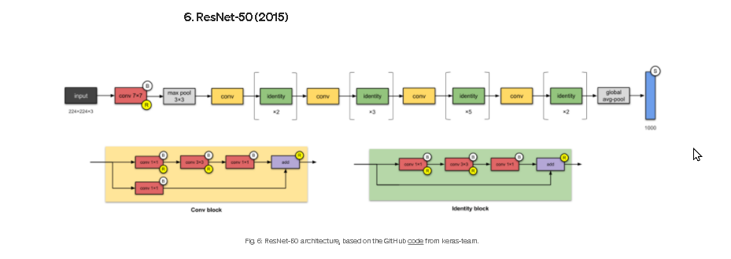

For more: https://towardsdatascience.com/illustrated-10-cnn-architectures-95d78ace614d#e276